#1:
- Intro
  - Make our actual logo
  - “WashU off campus housing” at the bottom
- 5 tabs 0 answers
  - Good, keep as is
- Reviews section
  - says “Read the receipts” at the top
  - Two listings, both show reviews - one bad, one good. Reference the mockup below
  - The reviews/listings to use
    - 7012 Forsyth Blvd
      - “The landlord made me fear for my safety.” - Rachel
    - 5959 McPherson
      - “Responsive landlord who is quick to help.” - Benjamin
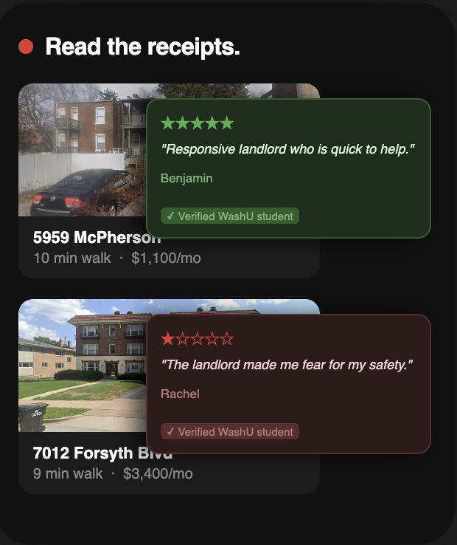

- CTA - the find your place. Skip the chaos. Slide
  - Make actual logo
  - Put useproximity.org somewhere - Browse listings or get matched CTA
#2- Explainer (would love to get in landscape format as well if possible)
- Intro - Ben films this; editor cuts and adds VO/effects
  - Ben and one other person sitting down in a nice apartment/living room, both raise glasses: "Wow, this place is perfect."
  - Slow down or freeze, VO over: "So how exactly did we end up here?"
  - Rewind effect (film grain or glitch cut), cut to Ben sitting down, opens proximity on his phone, camera zooms into the screen, fades into the next section
- "Find Your Place" -
  - “Find your place” Show 4 fields, each appearing and being selected in quick succession (~1 second each):
    - Group Size? - taps "2 people"
    - Budget per person? - taps "Under $800"
    - Move-in? - "August 1st"
    - What matters most? Pick 2 - taps "Walking distance to campus," then "Near restaurants & nightlife"
  - After last selection, "Match me with places" button pulses, then taps
- Results
  - 2 listing cards slide up from bottom of screen
  - Each card shows: property name, neighborhood, monthly price, star rating (e.g. 4.8), walk time to campus, walk time to shuttle stop, drive time to campus
  - Reference useproximity.org/browse for card layout direction - clean the design up
  - Below the two cards: one button - "Not sure yet"
  - Presses "Not sure yet"
- Proximity Concierge Chat
  - Header: Proximity Concierge - REPLYING LIVE, with a green dot (same style as existing reel)
  - Exchange 1: Concierge sends "Would you spend $50/month more to have a gym in your building?" - user replies "yes, does it include parking?"
  - Exchange 2: Concierge replies "Yes, utilities and parking included. We found the place for you." - new listing card drops in below (single property)
  - Clicks the card - card expands to show full listing detail. Specs:
    - Property photo at top (wide crop, 16:9)
    - Property name, neighborhood, and price per month
    - Star rating with number of reviews (e.g. 4.9 - 12 reviews)
      - Maybe one full review visible if it isnt too crowded
    - Short description, 2-3 lines, cut off with "..." (e.g. "Fully furnished units steps from the Loop with in-unit laundry and...")
    - Commute row: walk time to campus / shuttle stop distance / drive time
    - Amenity tags: 3-4 max (e.g. Furnished, In-unit laundry, Gym, Parking) - keep it to what fits in one line so the card doesn't feel crowded
    - Utilities included badge - small green tag that just says "Utilities Included" if applicable
    - "Request Tour" button pinned to the bottom of the card
  - Presses "Request Tour" - button confirms: "Tour Requested" with a checkmark
  - Keep exchange fast
- Outro - pretty much what you had already
  - Proximity logo, centered
  - "Find your place. Skip the chaos." centered below logo
  - Red pill button centered: useproximity.org/matchmaking
  - FREE FOR WASHU STUDENTS in small caps, centered below button
Other hook variations:
Note: both replace the cheers/rewind intro. Everything from "Find Your Place" onward stays the same. Pure motion graphics, no footage or screenshots needed.
- Open on clean white frame - silence for 0.3 seconds
- Screen shatters - no text, no context, just the crack
  - Fracture originates from a single center point, cracks spread outward to the edges, pieces fall slightly but don't fully disperse - frame stays mostly intact but visibly broken
  - Reference: Black Mirror intro on Netflix - that specific style of glass cracking outward
  - Audio: single sharp crack, then silence as the dust settles
  - Hold on the cracked white frame for 0.5 seconds - let the viewer sit in it
- "The off campus housing market is broken." lands over the cracked frame
  - Text arrives in 2 hits directly onto the fractured background - fracture lines visible behind and through the words
  - Hit 1: "The off campus housing market" - weighted drop, impact sound
  - Hit 2: "is broken." - lands slightly slower, slightly larger, like a verdict. Impact sound.
  - Hold 0.5 seconds - cracked frame + text together
- Pieces pull back together, screen reassembles
  - Fracture lines close, cracks seal, frame returns to clean white
  - Takes ~0.75 seconds - not instant, feels like something being repaired
  - Audio: reverse of the crack sound, or a clean low tone as it seals
- "So we fixed it." lands on the now-clean white frame
  - Single hit, Proximity red (#E23A2F), same bold typography
  - Hold 0.5 seconds
  - Proximity logo mark fades or assembles in below the text
  - Beat drops here
- Hard cut into form demo - beat lands on first form field appearing
Note: replaces the cheers/rewind intro. Everything from "Find Your Place" onward stays the same.
- Open on a clean white frame
- Screenshots build in 3 phases, escalating in speed and audio Audio direction: starts dead silent with isolated soft thuds. A low tension tone begins building under phase 2. By phase 3 the thuds are overlapping and the audio is almost overwhelming — then dead silence on the hard cut. Phase 1 — Slow (one every ~0.8 seconds, reader can absorb each one): Screenshot 1 - Reddit post, crop to title + subreddit + upvote count: "Any recommendations for apartments? I've only seen negative reviews on all the ones listed online." https://www.reddit.com/r/washu/comments/z5vwiz/any_recommendations_for_apartments/ Screenshot 2 - Reddit post, crop to title + subreddit: "Why is housing so difficult here" https://www.reddit.com/r/washu/comments/1sq8awg/why_is_housing_so_difficult_here/ Screenshot 3 - Student Life article, crop to headline + publication name: "WashU's rent is too damn high" https://www.studlife.com/forum/2024/12/02/washus-rent-is-too-damn-high/ Phase 2 — Medium (one every ~0.4 seconds, still readable but building): Screenshot 4 - Student Life article, crop to headline + publication name: "How to settle your housing drama" https://www.studlife.com/forum/2024/12/02/how-to-settle-your-housing-drama/ Screenshot 5 - Reddit post, crop to title + body preview: "I'm starting my PhD this fall… the only places I can find that are sub $1.1k have absolutely HORRID landlord reviews." https://www.reddit.com/r/washu/comments/1ckaqm0/dbbs_phd_students_how_much_are_you_willing_to/ Screenshot 6 - Student Life article, crop to headline: "New requirements for sophomore on-campus housing push juniors out" https://www.studlife.com/news/2026/04/02/new-requirements-for-sophomore-on-campus-housing-push-juniors-out/ Phase 3 — Fast burst (one every ~0.15 seconds, too fast to fully read — pure chaos): Screenshot 7 - Reddit post, title only: "Housing after sophomore year?" https://www.reddit.com/r/washu/comments/cz7l5l/housing_after_sophomore_year/ Screenshot 8 - Reddit comment screenshot from the David Zhang thread, crop to just the comment text: "He will illegally withhold portions of your security deposit" https://www.reddit.com/r/washu/comments/ybvc5g/dont_rent_from_david_zhang/ Screenshot 9 - Reddit comment from same thread: "Her apartment ended up flooding almost daily into the units below" https://www.reddit.com/r/washu/comments/ybvc5g/dont_rent_from_david_zhang/ Screenshot 10 - Reddit post, title only, this one lands biggest (slight scale-up on impact): "DONT RENT FROM DAVID ZHANG" https://www.reddit.com/r/washu/comments/ybvc5g/dont_rent_from_david_zhang/
- Hold on full pile for 0.4 seconds — audio cuts to complete silence
- Hard cut to clean black frame. Text drops in centered, white, bold: "Meet Proximity." Hold 0.75 seconds. Beat drops here.
- Cut directly into form demo. Beat drop lands on first form field appearing
#3 - 47 Tabs / Campus Distance combination
- Intro
  - Brookings Hall aerial photo - pull from Frame 1 of the "This is home." video, remove the "This is home." text that's on it in that draft
  - Text fades in over the photo: "You got in."
  - Browser tabs start animating on top of the aerial one by one until the campus is mostly buried - use 8-10 tabs from real sites: Zillow, Apartments.com, Facebook Marketplace, Craigslist, Trulia, Rent.com
    - Tabs pile on fast and overlapping - chaotic energy, not playful
    - By the end, Brookings is almost fully covered
  - Text: "Now find somewhere to live near it."
- The Clear
  - All tabs snap away at once - hard cut, not a slow fade
  - No text. Hold on clean aerial for half a second, then cut to white frame
- Proximity Intro
  - Text lands on clean white frame in two hits:
    - Hit 1: "Proximity."
    - Hit 2: "Off-campus housing with on-campus knowledge."
  - Hold 0.75 seconds
- The Reveal
  - Cut to phone showing the Five-Nine listing on useproximity.org
  - The Nearby Places section is visible on screen. Walk times animate in one at a time, each with a small pop, in this order:
    - Village House - 16 min
    - Sumers Rec Center - 18 min
    - Olin Library - 24 min
    - Danforth University Center (or use DUC if its cleaner) - 24 min
  - Star rating visible on the listing: 3 reviews showing, 4.7 average (real reviews, already live on the platform)
  - No text overlay needed here - the numbers speak for themselves
- CTA
  - Proximity logo, centered
  - "Minutes from campus. Miles from stress." centered below logo
  - Red pill button, brand red (#E23A2F): useproximity.org
  - FREE FOR WASHU STUDENTS in small caps, centered below button

